CO-4 ASSESSMENT-2
Q11 — Text Classification using NLP
1. Aim
To implement a simple text classification system using a Transformer-based NLP model and classify input text into different categories such as Sports, Technology, Business, and Entertainment.
2. Objective
The main objective is to understand how NLP models can automatically identify the category of a given text.
3. Software Used
- Google Collab
- Python
- Transformers library
4. Model Used
Zero-Shot Classification Model
The model classifies text into user-defined categories without requiring a separate training dataset for each category.
5. Categories Used
- Sports
- Technology
- Business
- Entertainment
6. Working
The system takes a sentence as input and compares it with the given categories. It then predicts the category that best matches the meaning of the sentence.
Simple Flow
Input Text → NLP Model → Compare Categories → Predicted Category
7. Algorithm / Steps
- Start the program.
- Load the text classification model.
- Define the required categories.
- Enter a text sentence.
- Send the text and categories to the model.
- The model compares the text with each category.
- Display the category with the highest matching score.
- Stop.
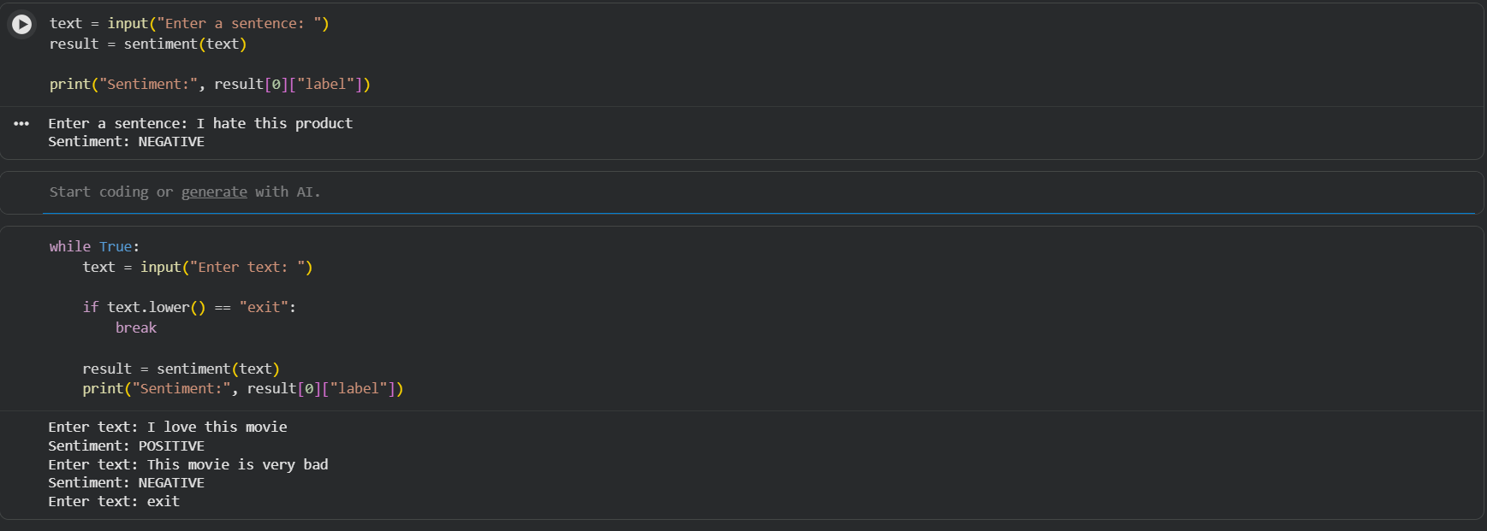

9. Applications
Text classification can be used in:
- News article classification
- Email classification
- Customer feedback analysis
- Social media analysis
- Document organization
10. Advantages
- Easy to implement.
- Can classify different types of text.
- Does not require a large training dataset for zero-shot classification.
- Useful for many real-world NLP applications.
11. Conclusion
The text classification system successfully classifies input sentences into suitable categories. This experiment demonstrates how Transformer-based NLP models can be used to automatically understand and categorize text.

Q17 — Sentiment Analysis using NLP
1. Aim
To develop a simple NLP system that identifies the sentiment of a given text as Positive or Negative.
2. Objective
The objective is to understand how NLP models can analyse text and determine the emotional opinion expressed in it.
3. Software Used
- Google Colab
- Python
- Transformers library
4. Model Used
Transformer-based Sentiment Analysis Model
The model analyses the input sentence and predicts whether the sentiment is positive or negative.
5. Working
The user enters a sentence. The NLP model analyses the sentence and predicts its sentiment.
Simple Flow
Input Text → NLP Model → Sentiment Analysis → Positive/Negative
6. Algorithm / Steps
- Start the program.
- Load the sentiment analysis model.
- Enter a sentence.
- Send the sentence to the model.
- Analyse the sentiment.
- Display the result.
- Stop.
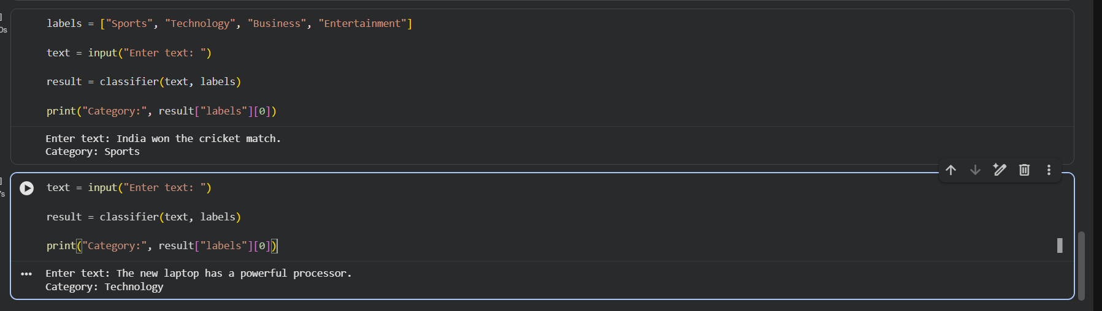
8. Applications
- Product review analysis
- Customer feedback analysis
- Social media analysis
- Movie review analysis
- Customer satisfaction monitoring
9. Advantages
- Simple and fast.
- Automatically analyses opinions.
- Useful for large amounts of text.
- Can help businesses understand customer feedback.
10. Conclusion
The sentiment analysis system successfully identifies the sentiment of input text as positive or negative. It demonstrates how Transformer-based NLP models can be applied to analyse opinions and customer feedback.

